**WEBTECH LAB DOCUMENTATION**

9421B

Group 2

ABAD, MARK JOSEPH COLOMA

ADVERSALO, AENEID ANTHONY MARIÑAS

ARBOLENTE, KATHLEEN DIANNE ANTONIO

BRAVO, MA. MICAELA PANLILIO

CABIGAS, MARYKNOLL NAZARETH MADRIAGA

DUCO, ELIJAH LEANDER GAGUTE

GUECO, JESSIRINE NICHOLE MONTEALEGRE

MINA, APOLLO JOSHUA DONAAL

SUBMISSION DATE : May -16-2017

**Admin Module -** The main technology that we have used is PHP. The framework that we have implemented was Bootstrap. Our functionalities are activating or deactivating accounts, messaging, and transactions. The admin has the capability of allowing a user or service provider to sign up in the website.

* They admin has the capability of accepting or rejecting the service, user, or service provider. Accepting and Rejecting is where can click the accept or reject button, the accept button can allow the service and give it a "go" signal to go to the user who requested that particular service or potentially deny the service, if due to causes that would lead the admin to deny that certain salon service.
* Messaging is where the admin can message a user or service provider and it also shows important information like when the message was sent and to whom it was sent to.
* Transactions is where the admin could see the transactions between the customer and service provider and it is recorded in the "Transactions" table.

**Service Provider Module –** Our functionalities as a service provider are to either accept or decline requests, edit our profile and receive notifications.

* For accepting requests, when a customer sends a request that is applicable with our service we will click the accept button. The decline button, if otherwise and if the request is not applicable or does not match well with the service provided.
* Like the customer, we could also edit our profile that could match the type of service provider.
* We can also accept notifications if the customer has sent a pending request that we can receive and could then start a transaction once approved.

**Customer Module** - we implemented Java as our main scripting side technology. Our functionalities are booking and searching services, sending a feedback to the service providers, and also edit the profile.

* For booking, the customer can book a salon service and a service provider.
* They can also search for services which the service provider can provide.
* For sending feedbacks, the customer can evaluate a service through using the feedback form and sending the evaluation where they could express their compliments or concerns.
* Customers can also edit their profile in case there were errors in their information that they have sent beforehand.

**Screenshots of Admin, SP and Customer modules**

**Customer**

1. Our website utilizes salon services. In here, you can see that there are different salon services such as facials, make up, hair styling, and nails. This is the homepage of the website and in here you can search these different salon services where the customer can type a salon service at the search bar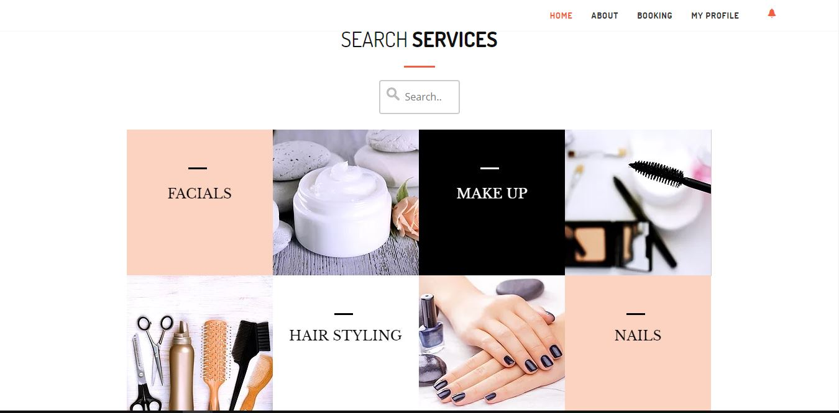
2. The interfaces as pictured above are where you can scroll these services as we also have searching services. The descriptions also describe a particular service, if the customer wants to request for a service. Customer can search for the service and the service providers will be provided through the search.
3. Once the customer clicks the “*MORE DESCRIPTIONS”* box they will be directed to the descriptions of a particular service they want to search with the use of the interface. 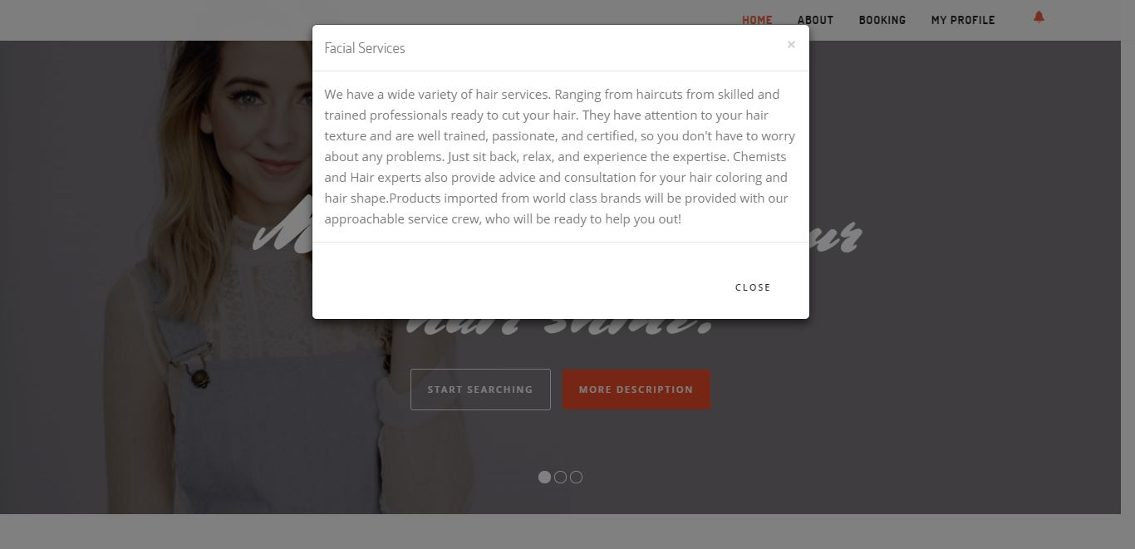
4. This is the customer registration form. The customer will fill out the information below and the information will be registered if they click the *“Register” button.*

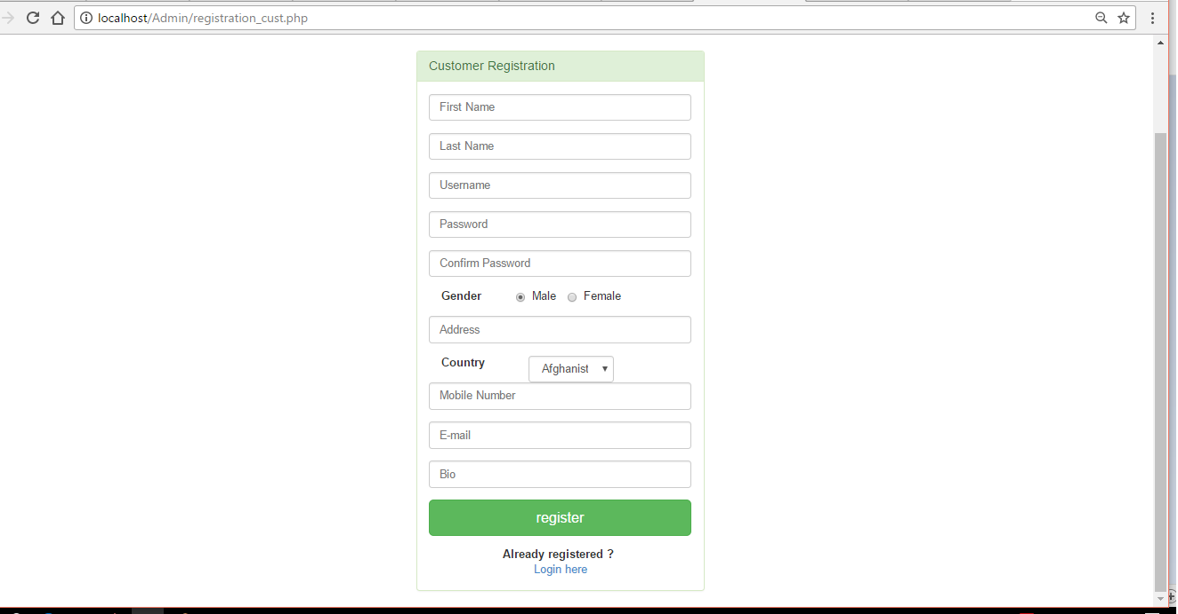

1. Now we move on to the “*ABOUT*” sections, this where the websites mission and vision is located.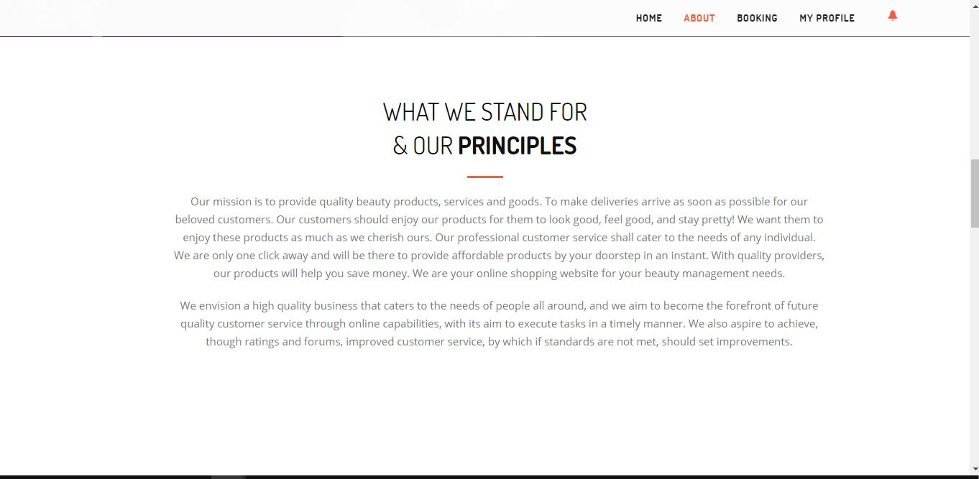
2. This where you can click these tags and the admin will redirect the customer to these media websites. As you can see above, we have Twitter, Facebook, Google, and WordPress. 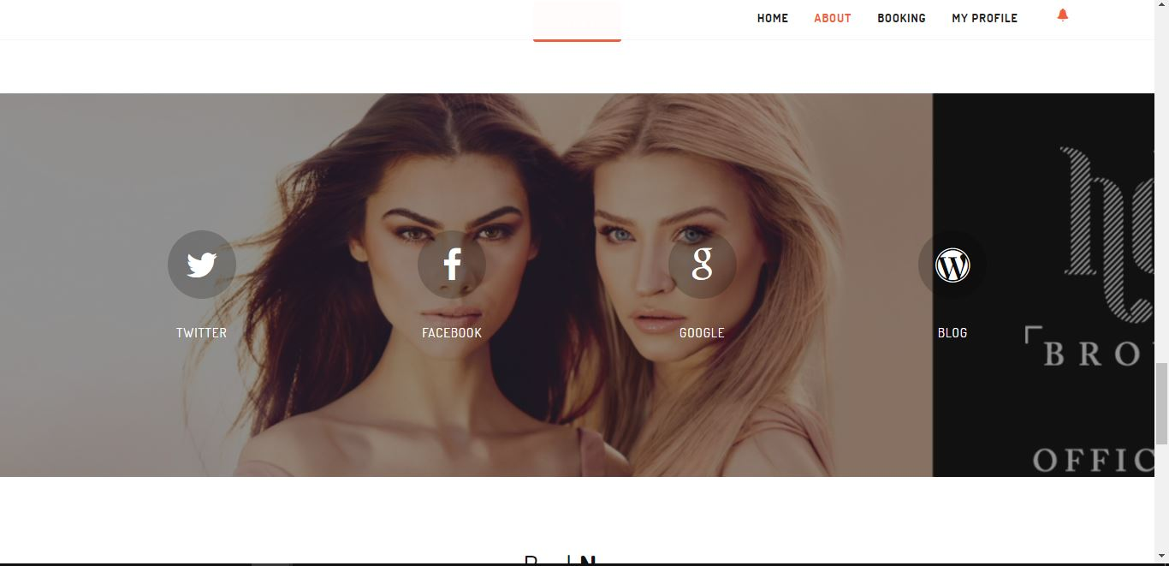
3. Now we move to the feedback, it is another functionality where the customer can give a feedback to the offered services and indicate if the services could be a compliment, complaint, or suggestion. It will be sent to the service providers so they can improve their services. After they type in their concerns/comments, they can finally submit the form.

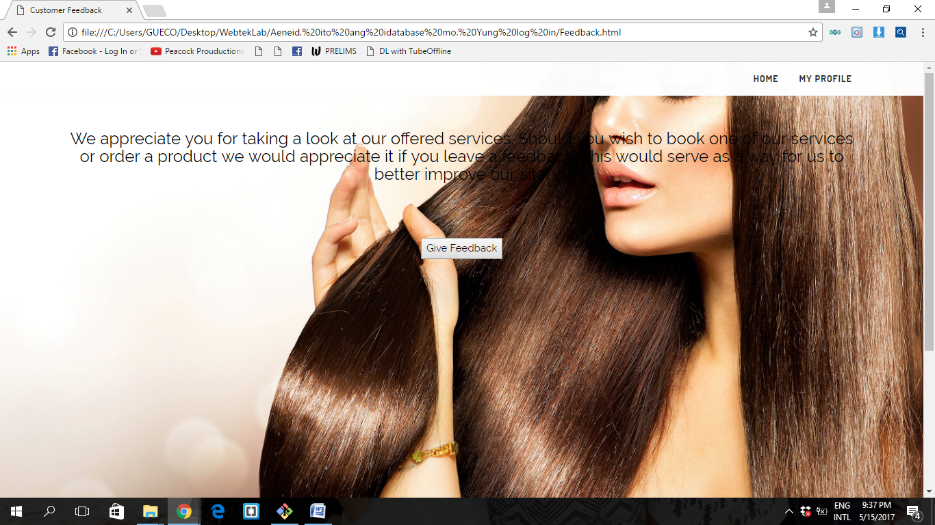

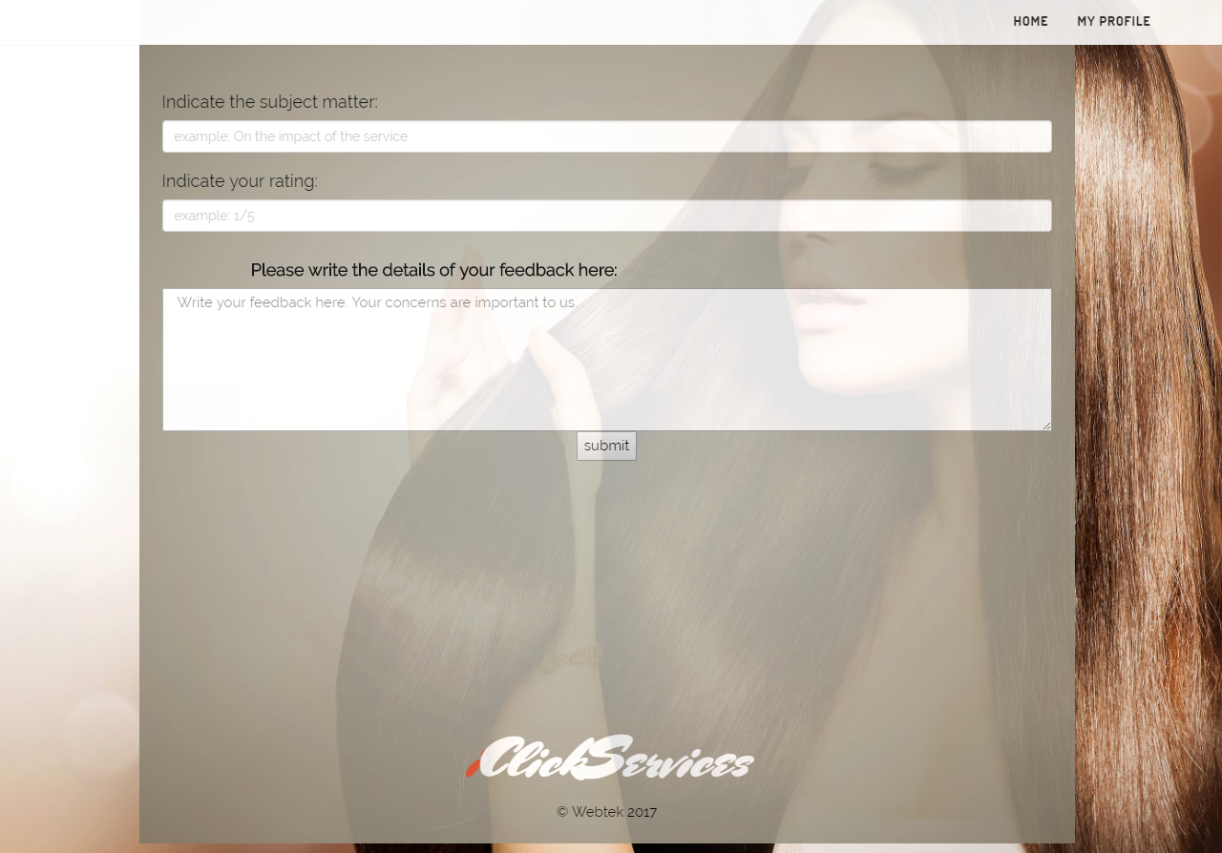

1. We go back to the search engine, once the user searches for an available service. They will be given the services that are available and that they could book them. Here is an example below.

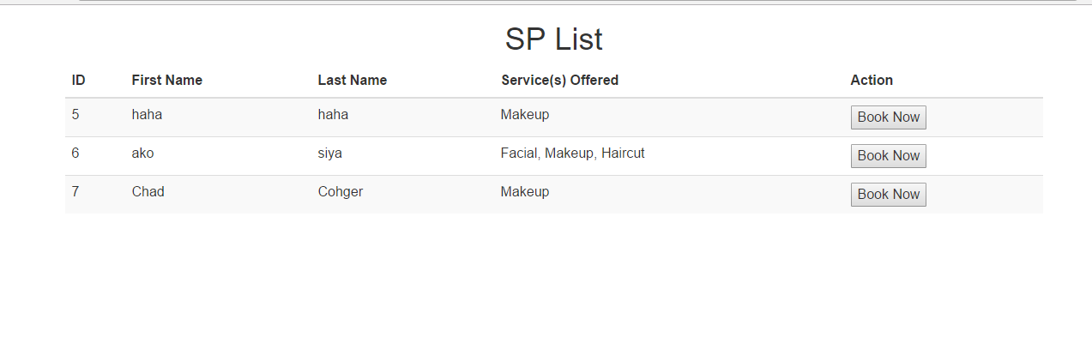

1. The customer also has the capability to edit their profile. Once they click on the profile tag as you can see, this is the main page for the customer’s profile.

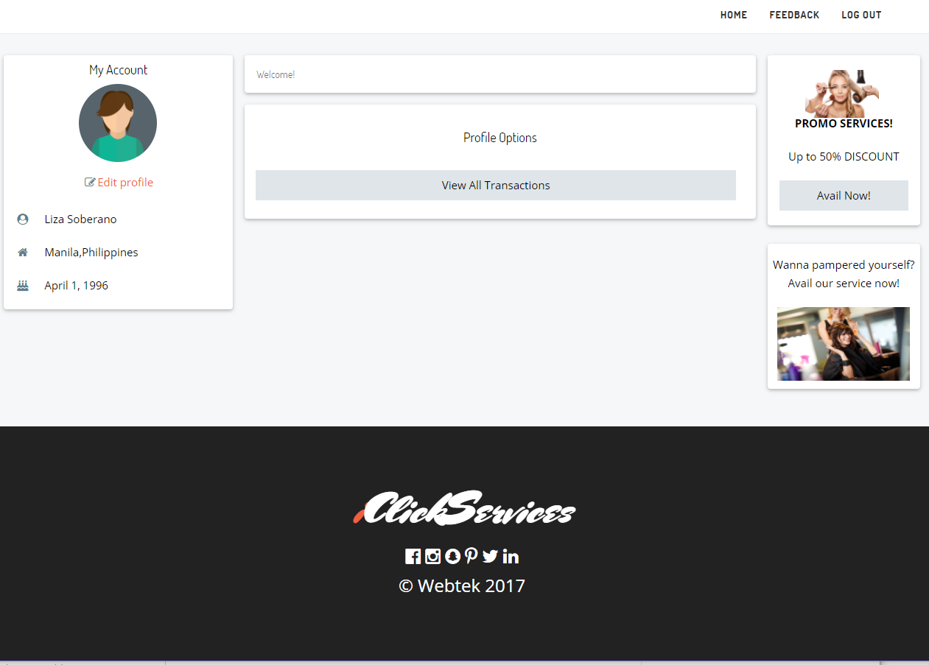

1. Here in the account settings, the customer can also have the capability to edit their profile. They could then save the changes after inputting the information.

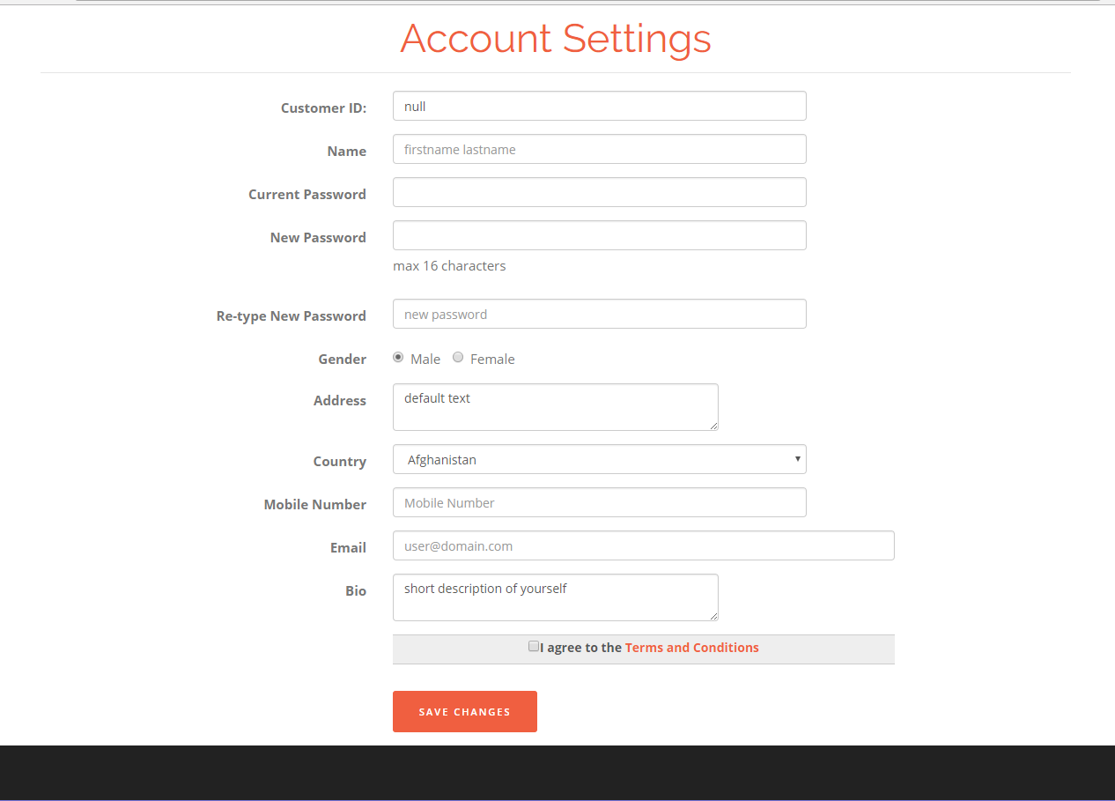

1. This is the Login page. The customer or service provider can login here, they just have to simply hover the mouse here and when they do hover the mouse to this circle here and login as customer or service provider.



1. This is where the customer or service provider can now login their username and password as a customer or service provider.

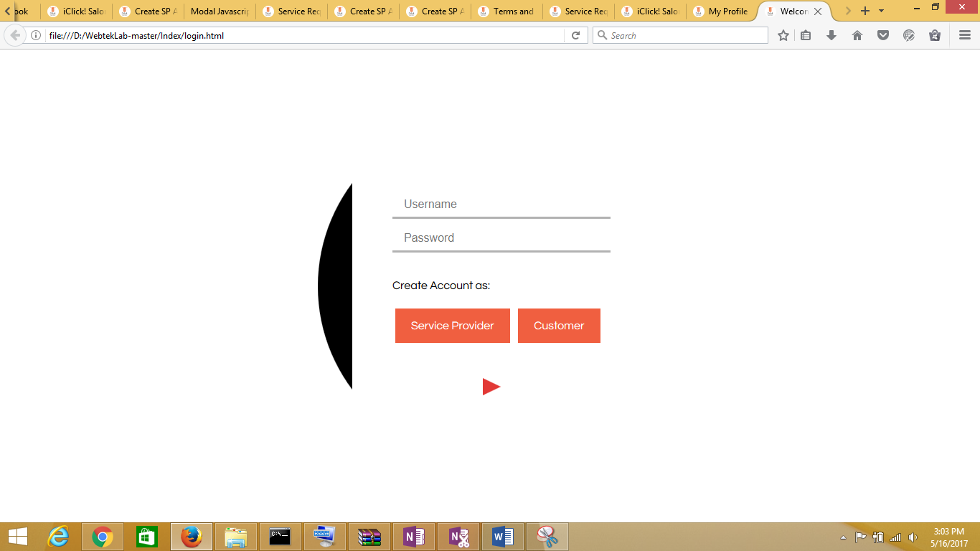

1. This is the user account of the customer. In here you can see the customers given information and that they can edit their information. Once the customer signs in their account, they will be given a chance to avail for special services. The customers can also interact with the service provider and transact with them surrounding their service.

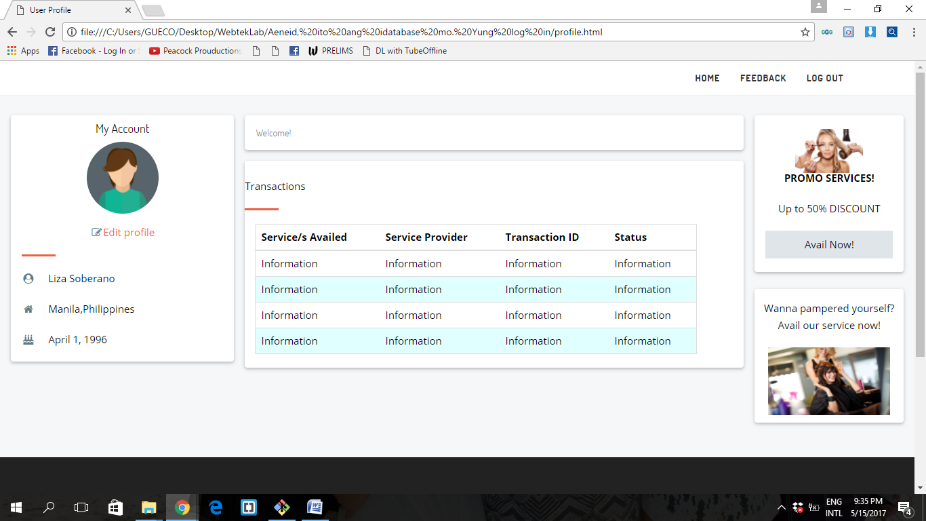

1. In this functionality the user/service provider could also edit their profile and save these changes should they be implemented.



**Service Provider**

1. So now we go on to the service provider module. It’s the same application as the customer logging in but this time they have to login as a service provider.





1. As you can see the information can registered once the customer has input the information and have been notified. 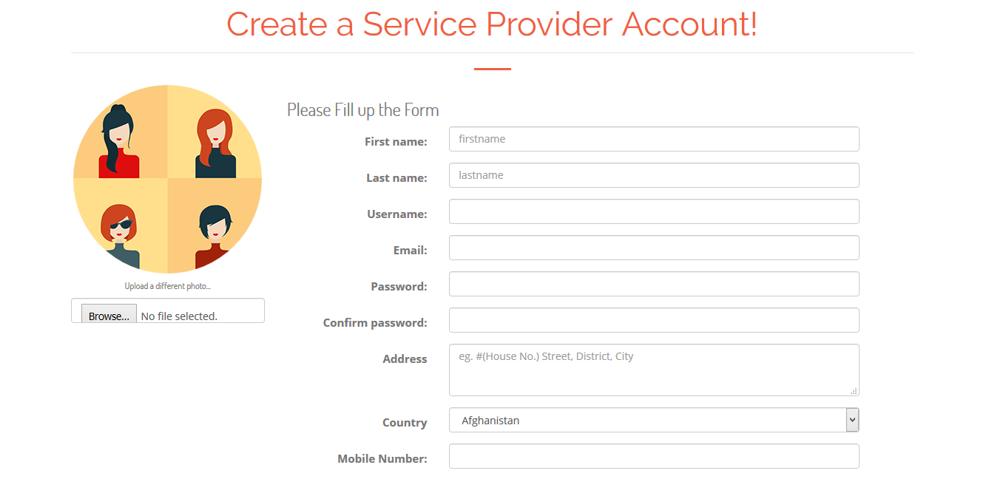

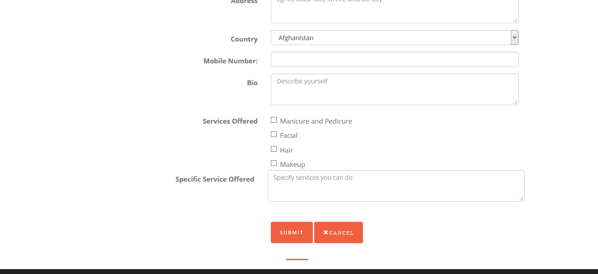

1. As you can see the registration for the service provider has been successful.

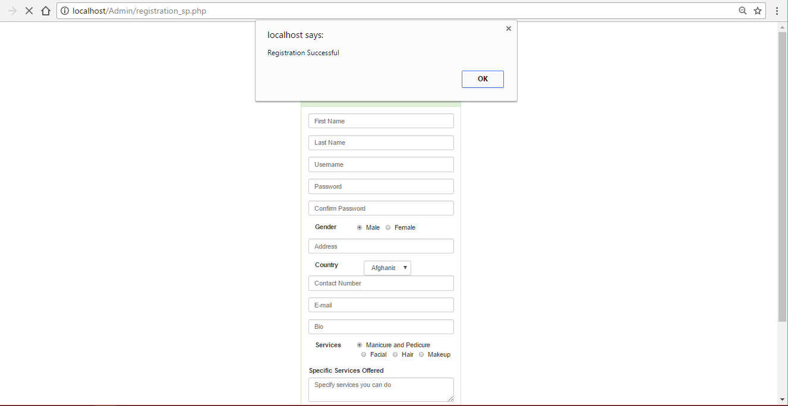

1. The service provider has the capability to also receive notifications should a client request a service.

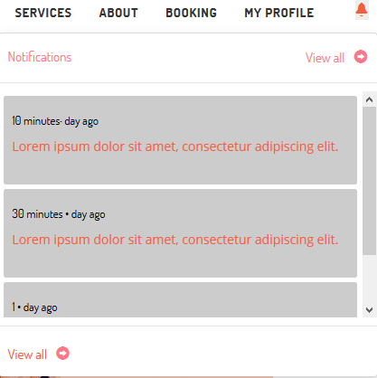

1. This is the homepage when the service provider logins. It contains the home, requests, about, and myprofile. The main bulk the service provider wants to look upon is the requests. Once the server provider clicks upon the requests, they will be lead here to the functionalities of approving or disapproving a service from a client. Transactions are also found once the service provider accepts the client.

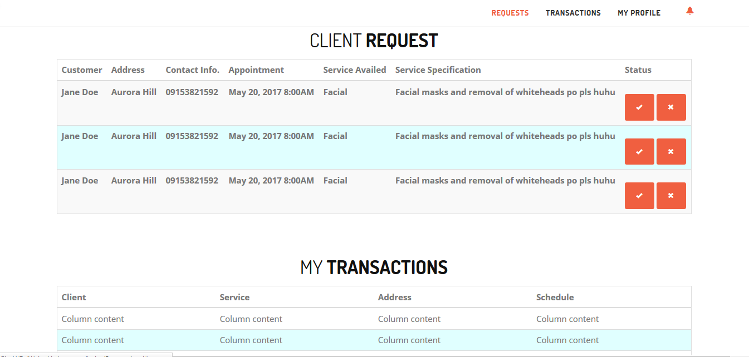

1. Now we can click on the “My Profile” section where it describes the service provider profile. Here we can see the information or personal data that was placed during the registration and transactions between the customer module and the service provider.

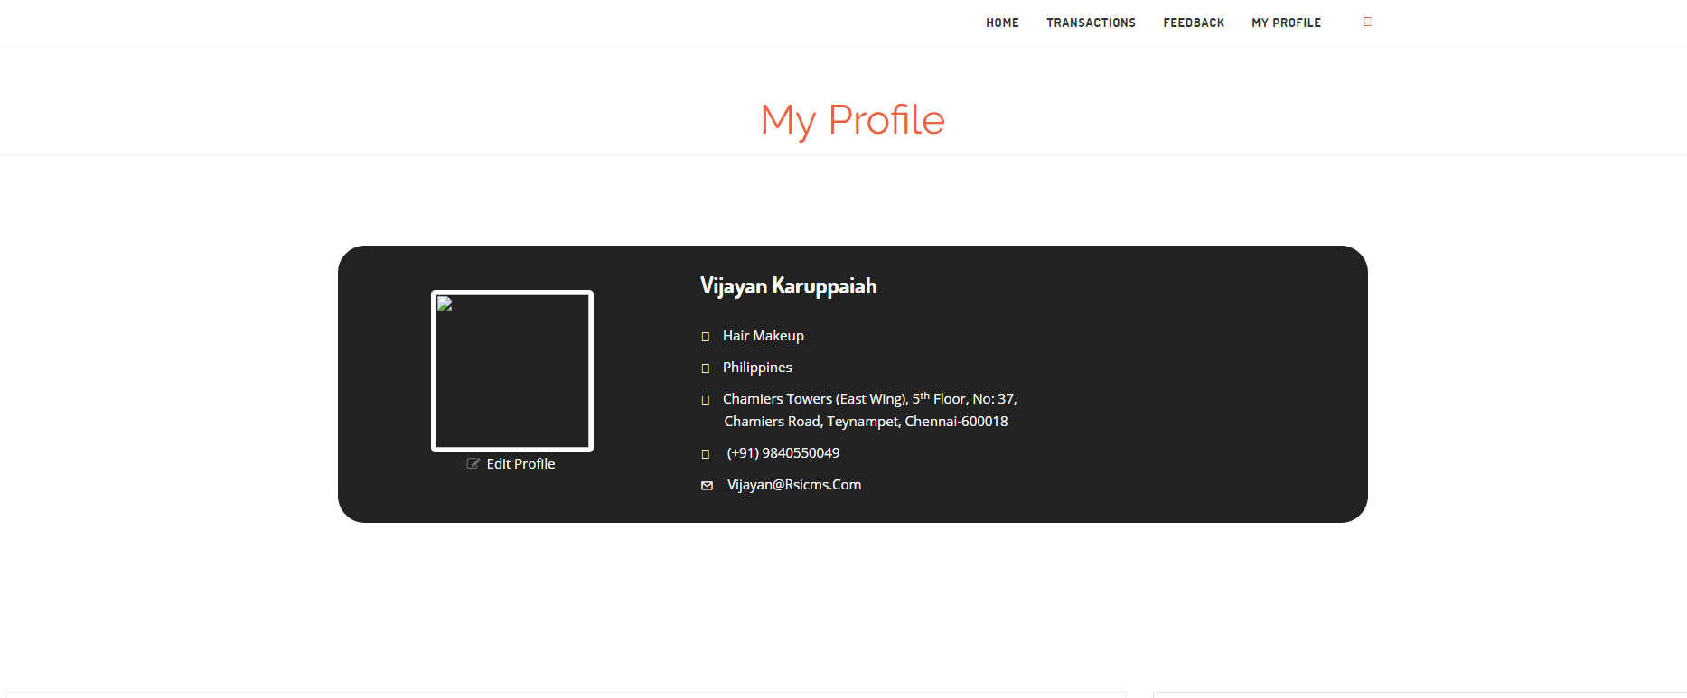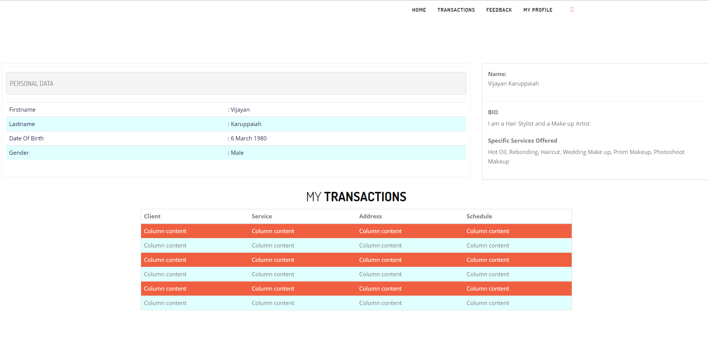

1. This is the feedback of the service provider regarding the comments of the customers.

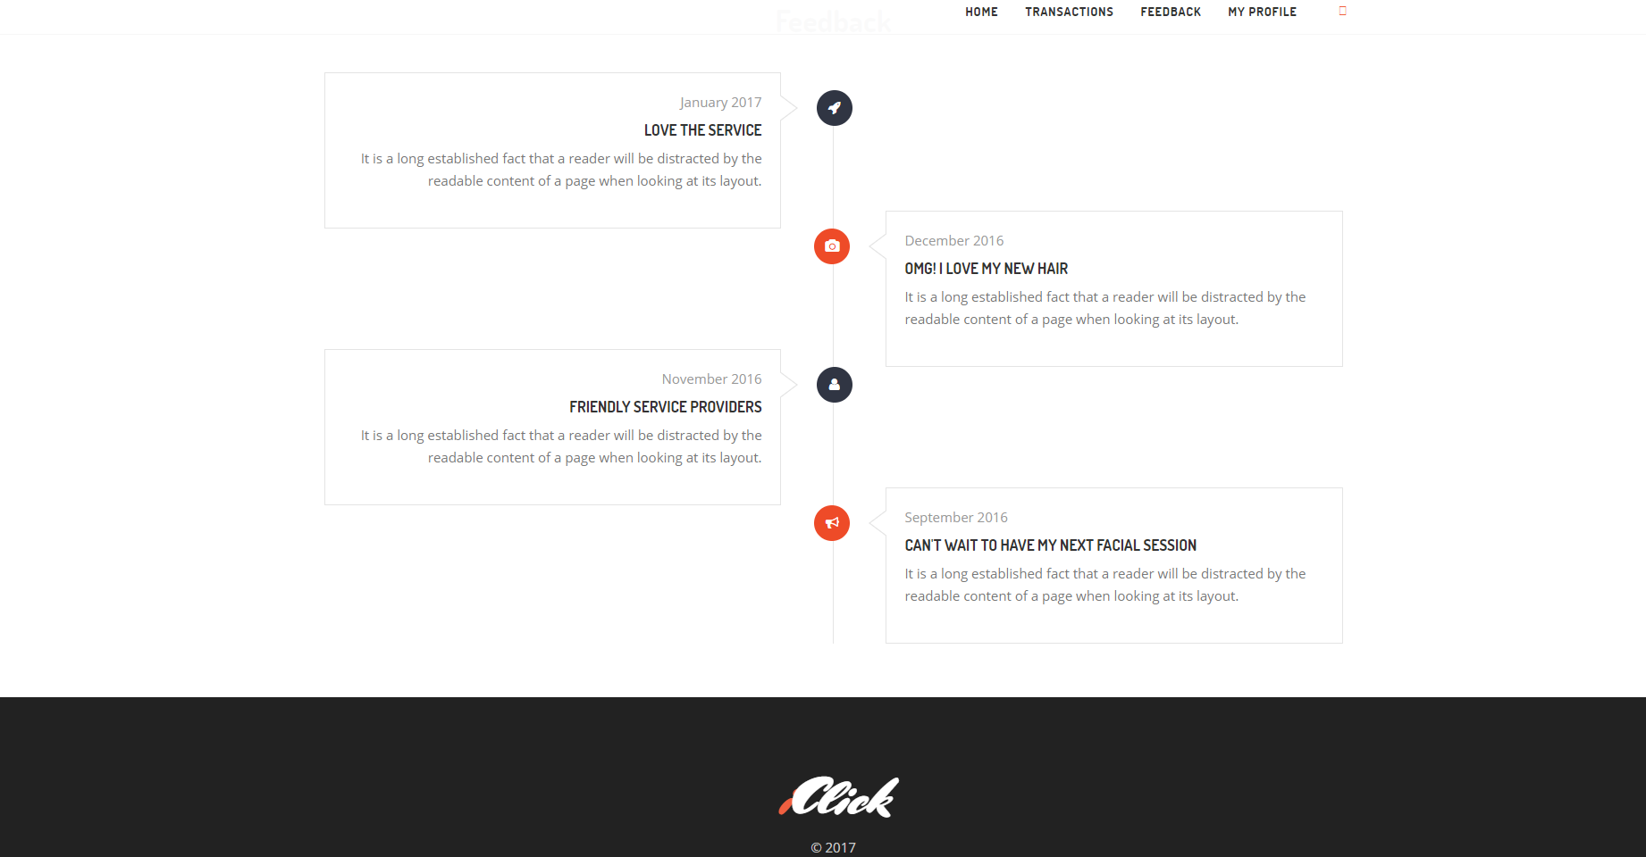

1. In this functionality the user/service provider could also edit their profile and save these changes should they be implemented. They can then save the changes.

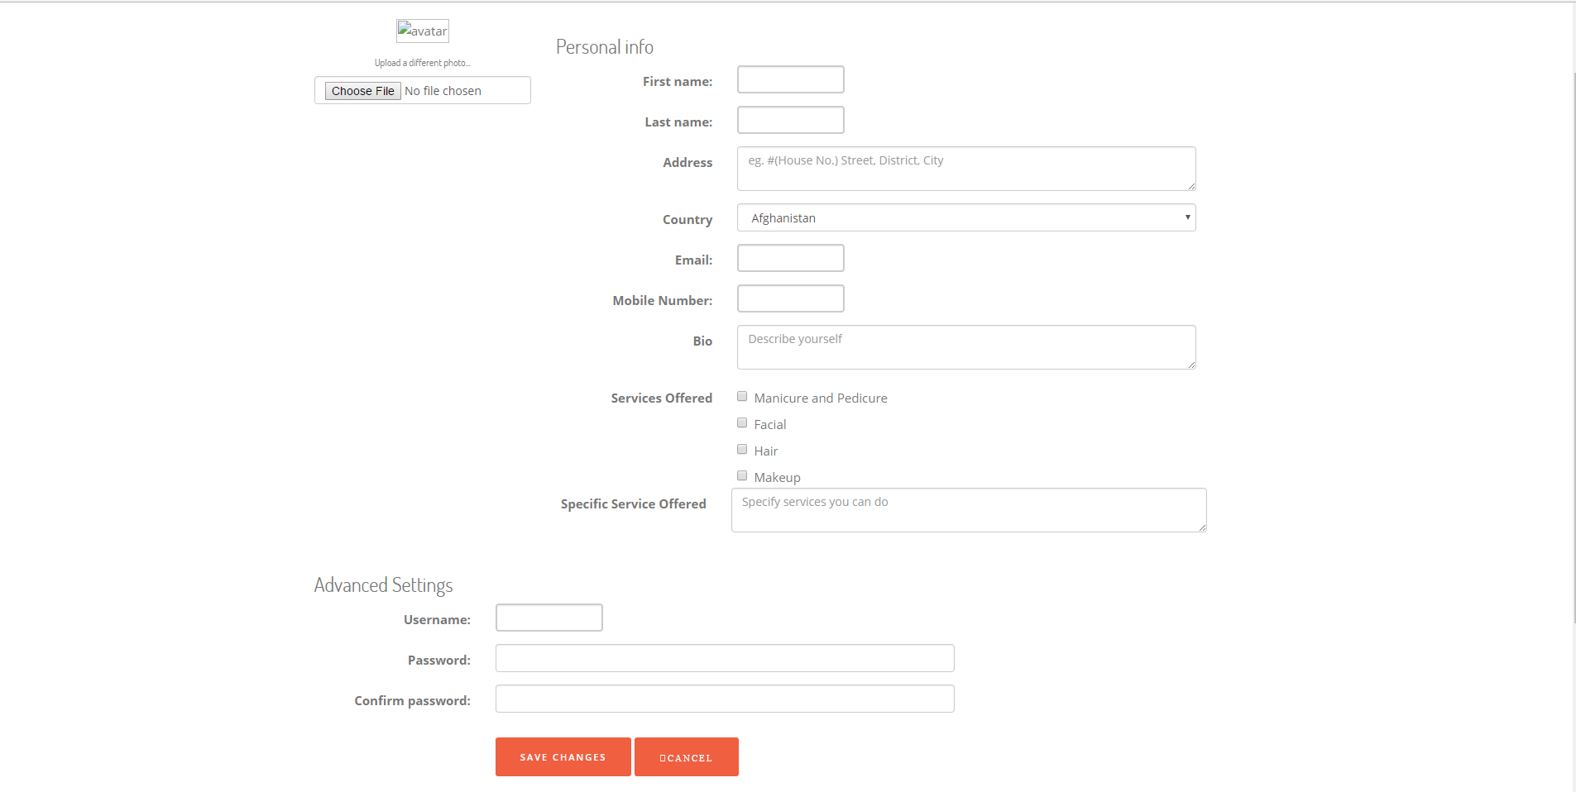

**ADMIN**

1. Now we have the login for the Admin. They will sign in by inputting the information.

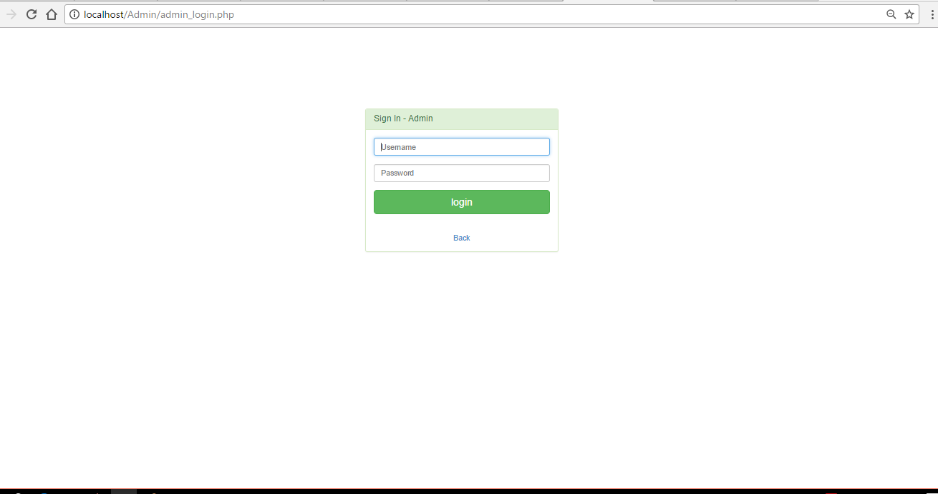

1. This is the login for the service provider in the admin module.

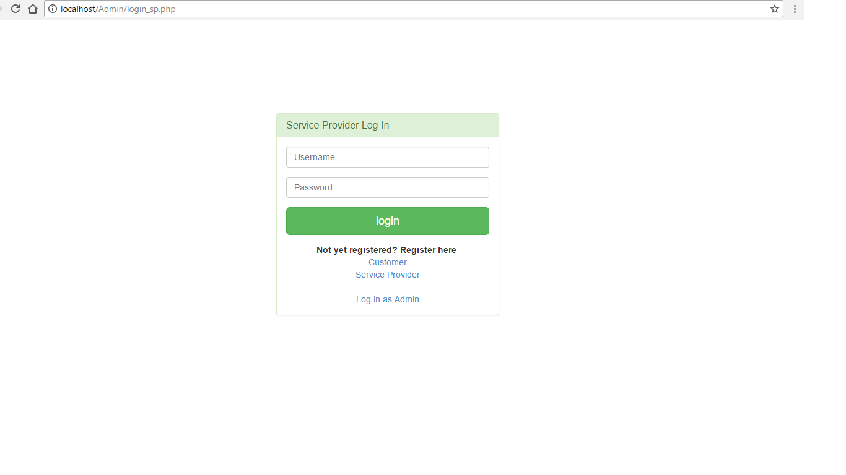

1. As you can see the registration for the service provider has been successful.



1. This is the login for the customer in the admin module.

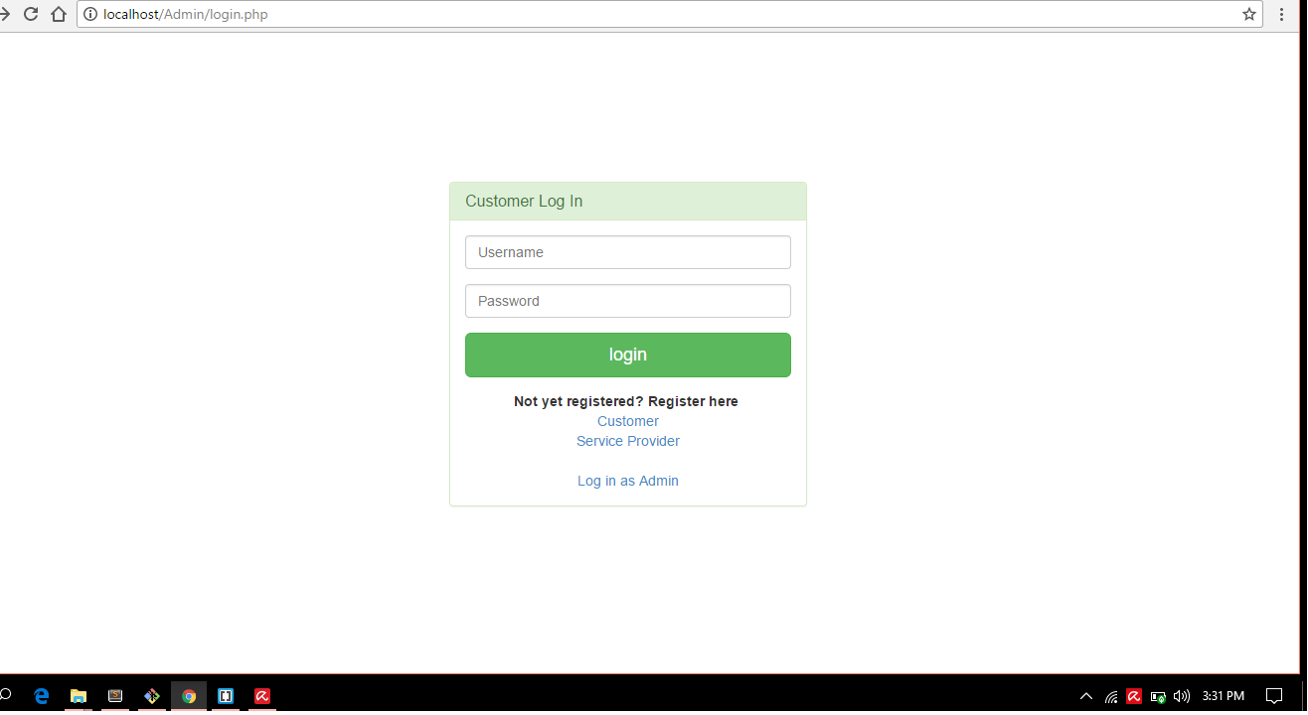

1. As you can see the registration for the customer has been successful.

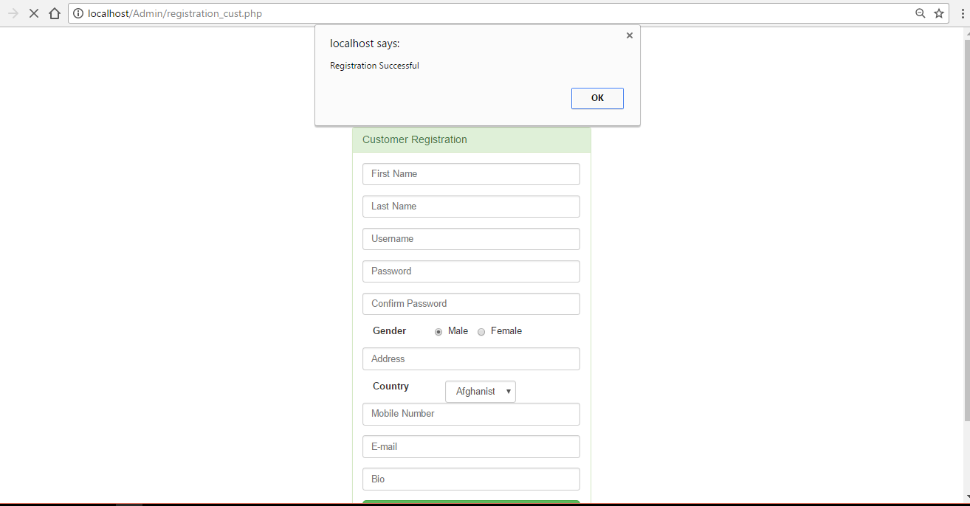

1. Now once the admin logs his account, he/she will be redirected to his page where he can monitor the Dashboard, Transactions, Client, Service Provider, and can even logout. This is where the admin can see the updated transactions and customers. The admin is even given an option to delete a user. The status below also shows that it can be either green “Activated” or red “Deactivated”.

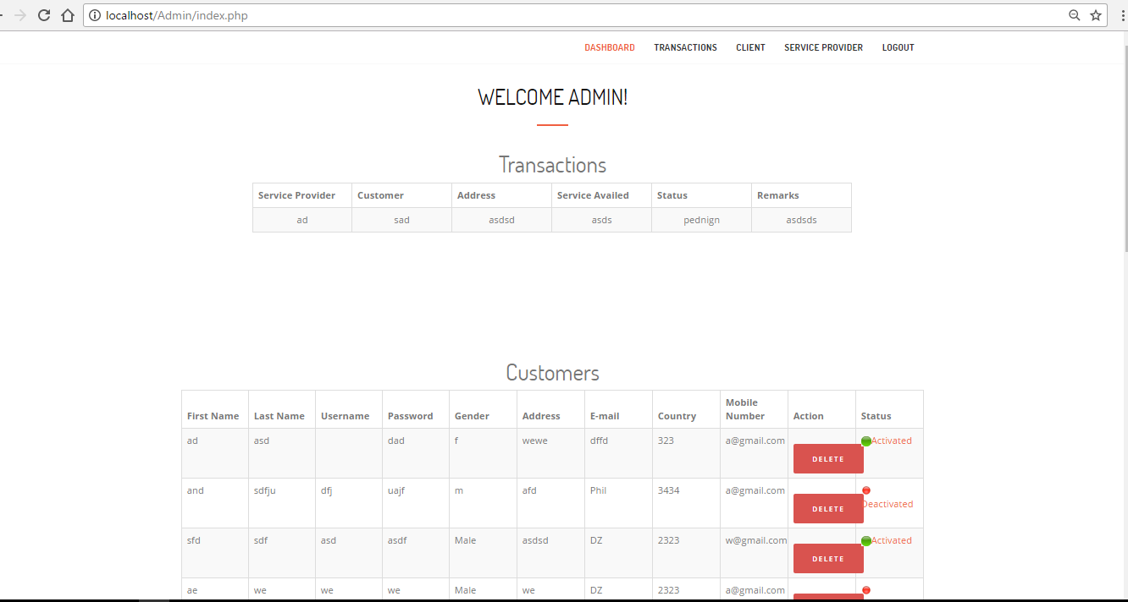

1. This is where the admin monitors the customers and as you can see there are the contents that describe the customers.

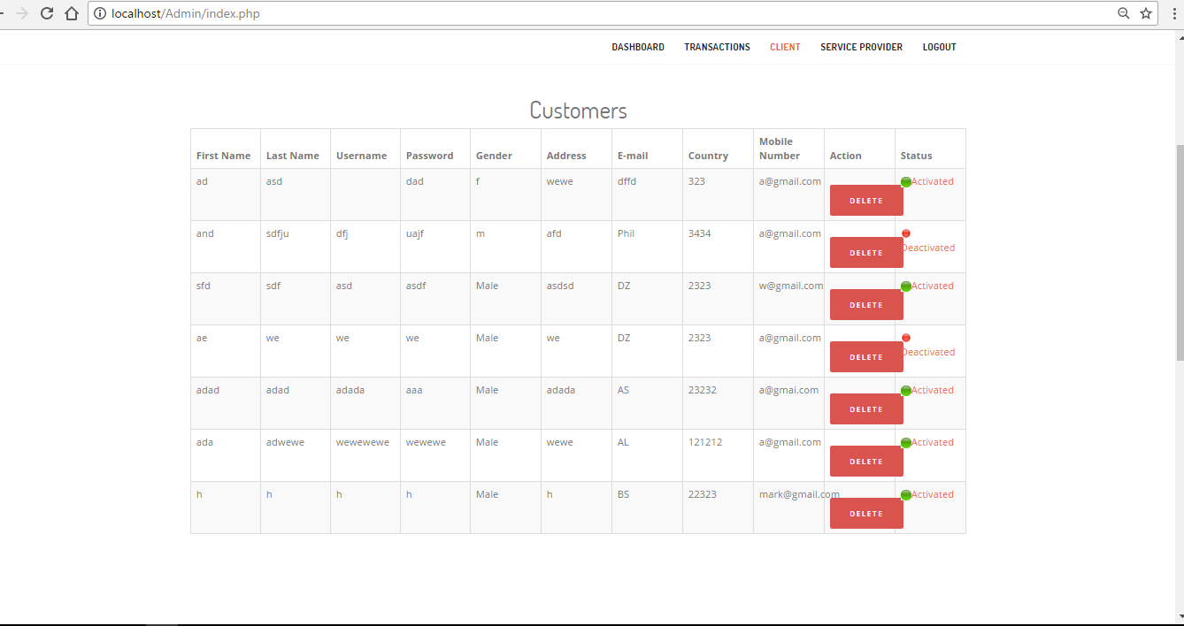

1. Now this is where the admin checks and monitors the service providers.

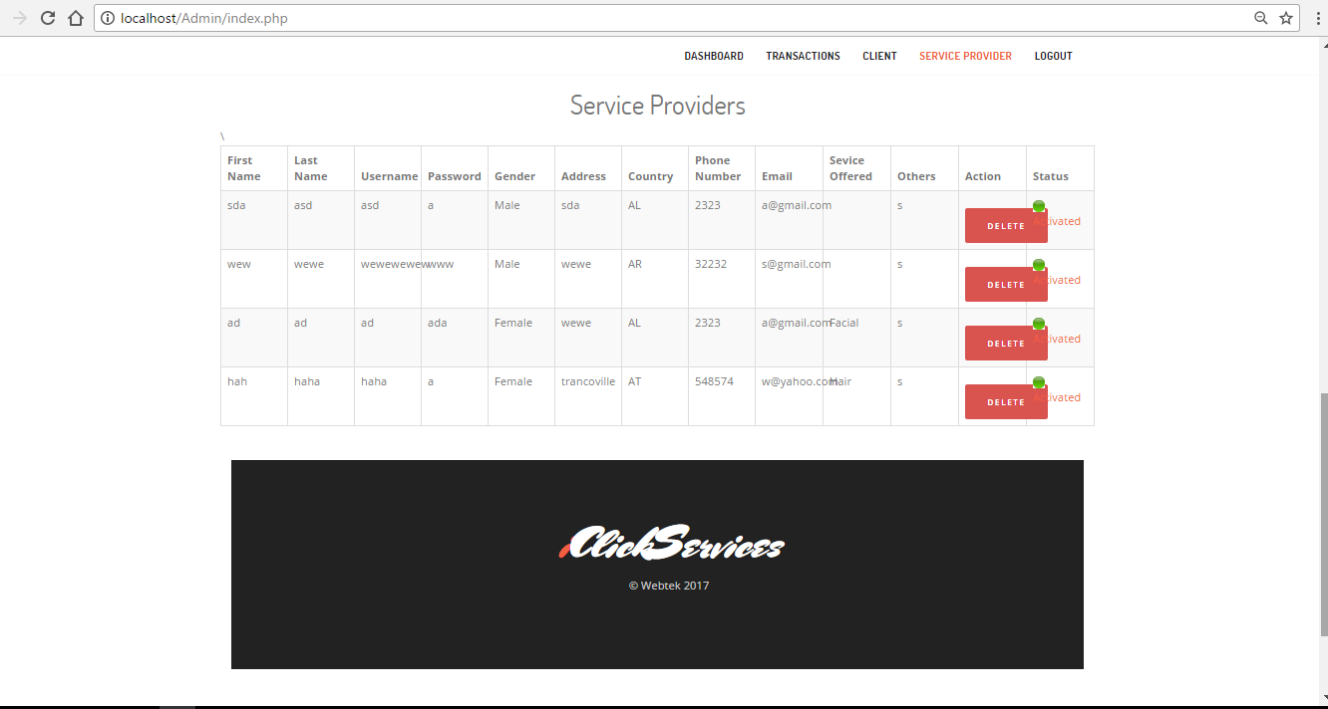

1. Last but not the least, we go to the terms of service. It is where the service provider, customer, and admin have to follow these set rules and apply them accordingly.

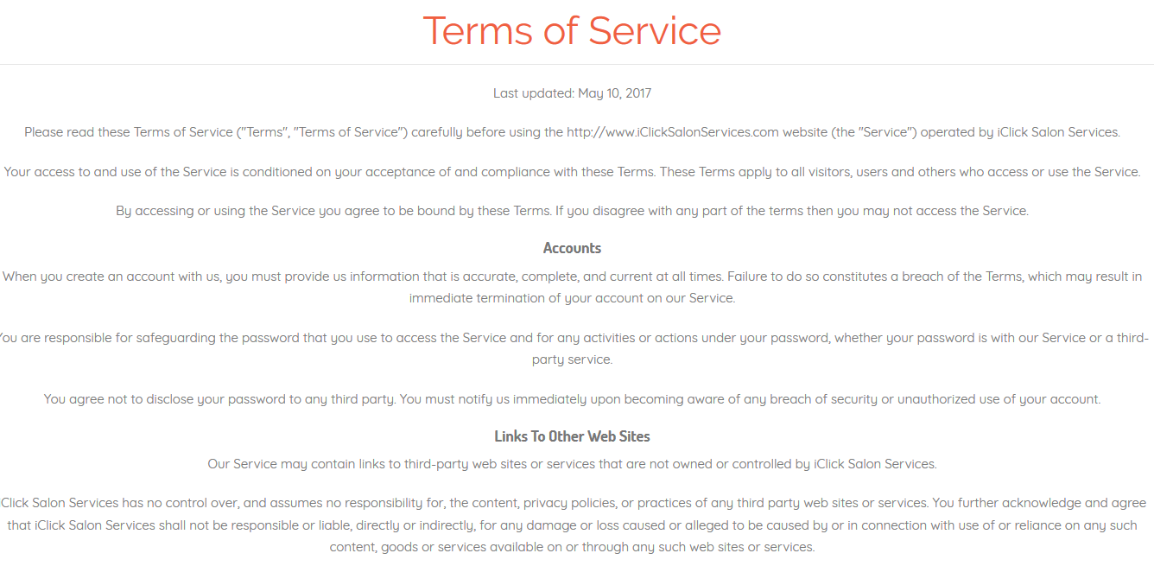

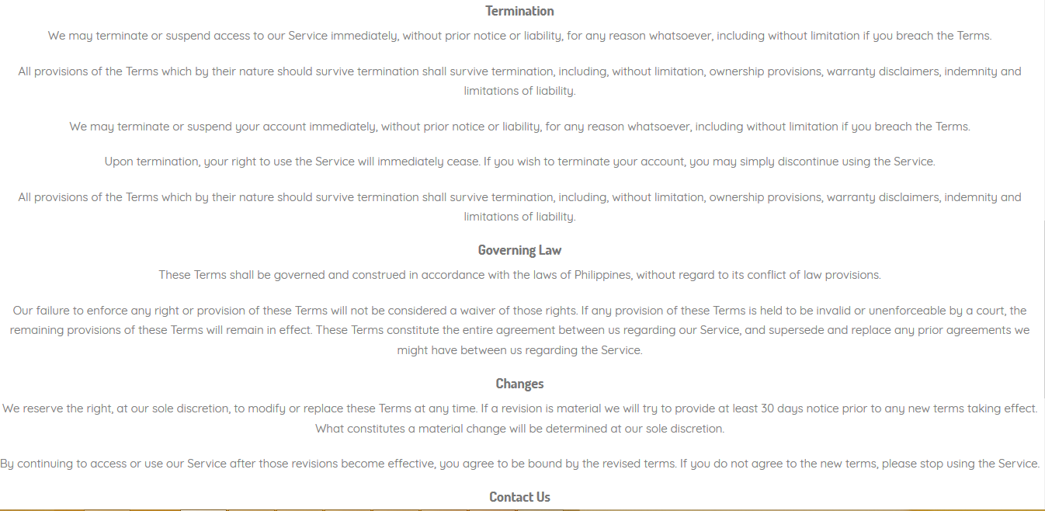

**Deficiencies**